**Day 2 of java Class Notes**

**Data Types in Java**

1. **Bytes** – 8 bytes
2. **Short** – 16bytes
3. **Int** - 32 bytes
4. **Long** - 64 bytes
5. **Char**
6. Boolean
7. Float
8. Double

* **String is class in Java also act as an Datatype**
* //we can access attributes directly in class methods but in main method we have to make object of the class in order to access the attributes of the class

**Strings in JAVA**

* **String is a class in Java**
* **It exists in lang package.**

1. **toString()**
2. **toUpperCase()**
3. **toLowerCase()**
4. **valueof(int)**
5. **toCharArray()**
6. **substring(int)**
7. **substring(***beingIndex*:int,*endIndex*:int**) // generally used- use case can be found in string.java file**

* **by default if we console object then it returns the garbage value (cuz gc method of lang.System class takes care)like `Strdemo@15db9742` but if we introduce toString in our program then it takes care and return what is returned using it .**
* **next() reads only one word till encounters space**
* **nextLine() reads wholeline until line changes**
* **we can only write body of toString method , but we cant for rest method as they are predefined.**
* **Whatever java takes or gives, it takes as string on black screen.**
* **String> (s1).equals(s2) method**

print vs println vs printf

Constructor in JAVA

* Constructor is a special member method which is invoked automatically at the time of creation of object of class.
* Types: -

1. Default Constructor
2. Parameterized Constructor

* Constructor name is same as of the class name.
* Both type of Constructor could remain in same class and could be used each at a time or simultaneously by creating two different objects.
* During the time of Object creation, it depends on how object is created with param or without param, based on that Default or Parameterized is called.
* There is no return type of Constructor.
* Syntax :-

Class A{

A(){

//Default Constructor

}

A(int a,int b){

//Parameterized Constructor

}

public static void main(String arg[]){

A x = new A(); // this will be automatically called as this is Constructor

}

}

*Check constructor.java for Example*

* `this` is a Keyword which refers to current object
* this() should be used in any one Constructor else it will lead to:
* 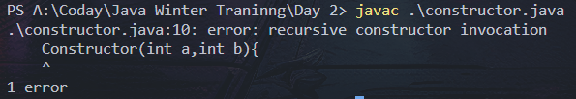
* Also this() should be used in first line else it will lead to :
* A screen shot of a computer

  Description automatically generated

Static Keyword in Java(M.imp)

* Static keyword is used for memory management only.
* It is used with Variable, methods and class.
* Static Variable are loaded in memory at the same time of class loading.
* The Values Static variables are shared among the object of class.

static Block

* Static Block are used to initialize static Variables.
* Runs before Main method.

Syntax:>

static{

……..

…….

}

static int c = 0;

    Staticdemo(){

        c=c+1;

        System.out.println(c);

    }

int c = 0; // for first set of inputs i.e. 1 , 1, 1

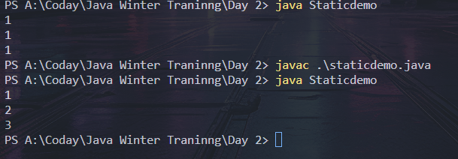

* Static 🡪 Default 🡪 Class Methods [Order of their run].